Annie Quach
Fall EDDN 680

SIOP Lesson Plan/Practicum Observation 1

Title of Lesson: Readers grow ideas by reaching for the exact, true, precise words to make their thoughts about the character.
Core Components
Topic of Lesson and Rationale:
Content Objective:
The student will be able identify character traits and provide evidence to support their theory.
Language Objective:
Students will be able to state a character trait verbally and be able to write it with sentence stems
Student Population:
This lesson is designed for fourth grade students. The class consists of a mix of ELL Proficiencies (entering, emerging, transitioning, expanding and commanding students). The student population consist of Chinese and Spanish students. There are three emerging, four transitioning, five expanding, six commanding, and the rest are non-ELL students.
Learning Community:
The elementary school is in District 20, in an urban community. The demographics of the school is Asian or Pacific Islander (68%), Hispanic (20%), White (11%), Two or more races (1%), Back (<1%), Native American (<1%), Native Hawaiian or Other Pacific Islander (<1%). The class is a mix of proficiency levels. Students are seated in tables of groups of 4- 6 students, with a total of 25 - 30 students in the classroom.
Materials/Resources:
You will need the following: Smartboard prepared google slides, character trait and definition cards, Tiger Rising by Kate DiCamillo, Animated Pixar Clip (https://www.youtube.com/watch?v=9IYRC7g2ICg), Character trait task cards, Jared to the Rescue passage by, Carole Duncan Buckman, sentence starter prompts.

SIOP Components and Explanation
1. Preparation
While planning this lesson on google slides, I collaborated closely with my cooperating teacher. The teaching point was visible on every slide and made sure to refer back to it often. Teacher modeling is evident and student practice is included. In preparation to this lesson, changes were modified to cater to the diverse learners in the classroom. Sentence stems are on each slide for students to refer to, to help them push their thinking. All teacher modeling and student sample responses needs to be shown. An animated Pixar video, “Geri” at the end of the lesson is used to engage students to practice the skill of finding precise words to describe the character. For independent work, students can practice this skill with a short reading passage, “Jared to the Rescue”. For a small group instruction, target the students who struggle orally getting their ideas across their page. Use character trait- task cards and work in partnerships to practice the skill of finding precise words to describe a character.
2. Build Background
Begin the lesson with reviewing what character traits are by using the anchor chart. Then review some character traits that students have already learned within the last few weeks. Display the chart with character traits, definitions and pictures.
3. Comprehensible Input
It is important to have the objective written down and visible throughout the entire lesson and refer to it often. Make sure you emphasize on the focus, choosing precise words to describe characters. For the lesson, in the teach model and student practice, choosing a familiar text can give the students an opportunity to make the connection to the skill. The text should be visible to all students. Preparing the text before- hand on the document camera or in your slides would be beneficial for students to follow along as you refer to it. Anchor charts and mini tools should be provided for this lesson. Make sure that the class vocabulary and reading wall is updated with new content vocabulary. It has to be presented for students to refer to when necessary. Teaching to ELLs, use a slower rate of speech during instruction. Model the skill using prompts and sentence starters. Consider having students repeat directions back to you or partners before starting. Make sure there are multiple resources included for independent work.

4. Strategies
Connect this lesson to their reading unit and the work that they have been working so hard on the last few weeks. Start with a little review of what a character trait is and what it means to choose precise words to describe them. Remind them of the character traits list and cards they have as a tool. Refer to those juicy words while describing characters. Use the anchor charts below:
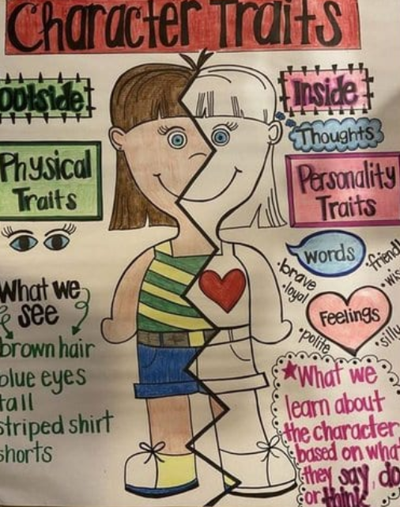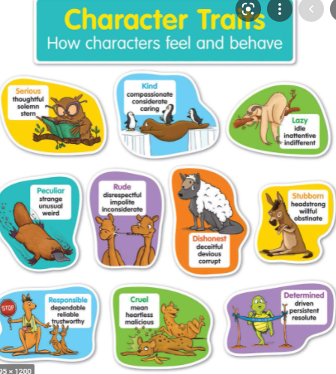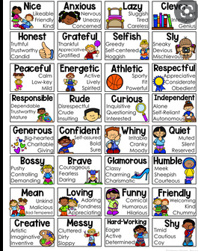
Then discuss how readers can infer about character traits. Review the word infer. Include a mini definition underneath the word infer. Remind students to infer about character traits, we pay attention to characters feelings, dialogue, actions, and thoughts. Use the chart below:
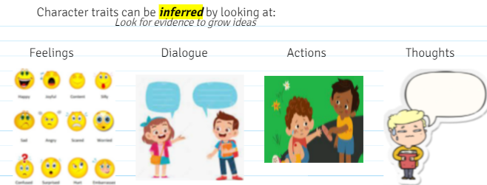
5. Interactions
Students should always have multiple opportunities to turn and talk and turn and analyze with classmates. Conversations with smaller groups give students time to process what is being asked and talking with other students can give clarification before sharing as a whole. Partnerships at the meeting area should be strategically set- up. Partnership roles are assigned as well, such as partner A and partner B. Small group target instruction should be grouped based on student data, such as pre- assessments and assessing students from prior units.
6. Practice/Application
Students will be provide snapshots of passage from the text, Tiger Rising on the smart board. They can follow along as you read and they can use the text in front of them to build on their idea during turn and talk discussions with classmates. For independent work, they will continue practicing the skill of choosing precise words to describe a character with a short story passage, Jared to the Rescue.
7. Lesson Delivery
The objective would be on every slide. Prior to the lesson, choose chapters or passages that have been read aloud to the students. Using texts that have been read aloud already, can allow students to make connections easier. Emphasize on the word precise as you teach the lesson. Show your model responses on the board. Have the sentence starter stems available and encourage students to use the sentence stems when they share. See the sentence stems below : 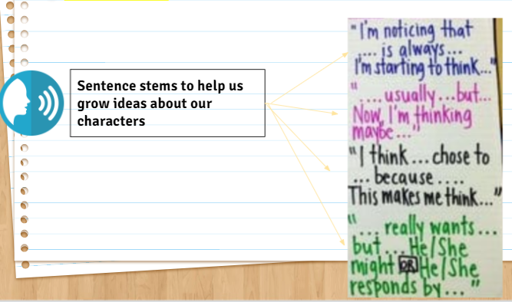
Remind students to use character trait tools that are in their notebooks. After modeling with one character from the read aloud, have students try it with another character. Partners then share their responses. Student then have another opportunity to practice the skill with an animated Pixar clip, Geri. Then students independently practice the skill with a short passage, Jared to the Rescue.

8. Review/Assessment
Students will share their sample responses. Part of their responses should include a list of possible traits to describe a character and one circled that best described the character. It should also include a short response that includes a detail to support their thinking. Student work will be collected as an exit ticket to see which student needs extra support and this can guide further whole class instruction.
9. Extension/Homework
Students will continue the skill when they are reading independently their leveled books at home. They will focus on the characters in their book. Their responses should be orally rehearsed aloud using sentence stems before writing a short response.

Section II: Lesson Plan Commentary
Reflection
This reading lesson is beneficial to ELLs. This lesson was created based on the students’ pre- assessment and data from previous lessons on character traits. My cooperating teacher and I noticed students choosing traits that were either incorrect or not precise enough for the character. Some students always chose the same words repeatedly. Those were the words they were comfortable and familiar with for using to describe characters. I included practicing writing their responses because their writing about reading (short responses) needed extra support. This lesson could be challenging for ELLs, but with tools, such as their pictured character trait cards and anchor charts, they can feel a little more confident in coming up with precise words for a characters.
I think it is also important to provide opportunities for students to work in partnerships. It gives them a chance to spark ideas from other students and gives them a chance to feel confident in coming up with ideas before sharing it with the entire group. Students should have some sufficient time to themselves to process what is being asked and to come up with one or two story character traits themselves first. It is also important to include big, open-ended questions. Higher order level questions allows you to supporting their language development and critical thinking.
It is crucial for the teacher to constantly model. Providing a model can eventually internalize the students’ thinking process and the students can do it independently. A change I would make is to have the questions I am asking during my thinking aloud and to the students shown on the board. Therefore, they can hear it and see it as well. Depending on the status of the students, and how much support they need in this unit, I would include another teacher model with another character in the book before the students have a go with it. Their responses can be shared orally, but it is also important for ELLs to have the practice in writing their responses
For future skill specific activities, I can consider using appropriate graphic organizers with sentence starter prompts to help students grow their ideas. Not all students would need it, but that can give students that need the extra support to feel confident and participate. I would also continue to give tools and provide charts with pictures that pertains to the skill that will be taught to the students.

