Annie Quach
EDDN 680
Fall 2021
Professor Lin
ELL/ ENL Assessment

Based on the NYSED English Language Learners (ELLs) Screening, Identification, Placement, Review, and Exit Criteria handbook, identifying English language learners is generally a two-step process, screening and ELL identification Assessment. The first step in screening in a Home Language Questionnaire. If the home language is other than English or the student’s primary language is other than English, an individual interview must take place, which would be step 2 of screening, the individual interview. Part c of the screening is students with IEPs. If the Language Proficiency Team (LPT) determines that the student with an IEP may have second language acquisition needs, the LPT will determine whether the student shall take the NYSITELL. The Language Proficiency team will also determine if the child needs testing accommodations or not. The next step is the identification Assessment. Qualified personnel will administer the statewide English language proficiency identification assessment, the New York State Identification Test for English Language Learners. The NYSITELL is administered only once within 10 school days of the student’s initial enrollment in a NYS school. . Based on NYSITELL results, students will be categorized into one of five levels (Entering/Beginning, Emerging/Low Intermediate, Transitioning/Intermediate, Expanding/Advanced, and Commanding/Proficient), which will determine the number of hours of services each student will receive.

Student A is a 4th grade transitioning ELL student. The writing assignment is a pre- assessment for opinion writing. Based on the 2018 NYSELAT Rubric for Grades 3-4, his writing sample shows that he is capable of including simple sentences and attempting to include some complex sentences. He is working towards including more expanded and complex sentences. This writing piece contains some Tier 1 and some common grade level tier 2 words and short phrases. The student includes sentences that connect his ideas. This student includes some detailed descriptions that relate to why people should not litter. There are some errors that obscure meaning, but for the most part, his writing is clear.
Based on the Teacher’s College Reading and Writing Project rubric, student A’s writing sample shows a clear understanding of essay organization. He was able to come up with a claim that was introduced in the beginning of his writing. This student was also able to organize his reasons into different paragraphs. These students' next steps are to include precise vocabulary to convey their readers to agree with them.

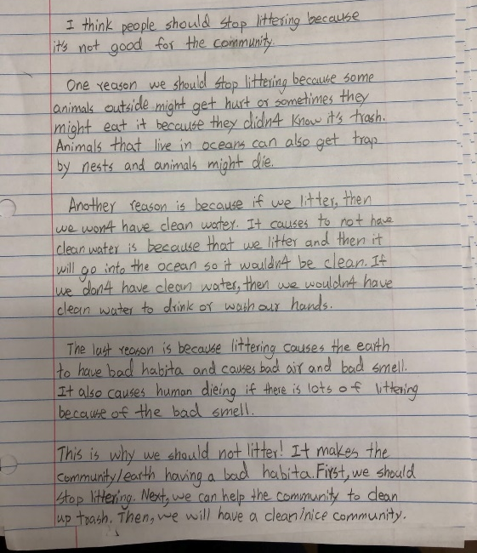
Student B is a 4th grade transitioning ELL student. This writing assignment is a pre- assessment for opinion writing. Based on the 2018 NYSELAT Rubric for Grades 3-4, her writing sample contains Tier 1 and common Tier 2 words and short phrases. She needs extra support in developing complete thoughts. Student B needs to work on including more Tier 2 words and sentences that are more complex. This student includes a clear thought in her first sentence, but needs to work on including detailed description throughout her writing. The writing has a limited introduction and development. Her writing contains a few errors, but it is clear.
Based on the Teacher’s College Reading and Writing Project rubric, student B has a clear opinion stated, but needs to work on organizing her writing into paragraphs and form complete sentences. Her next steps are to elaborate on each reason with descriptive details. She can also work on adding precise words to persuade other readers.

2018 NYSESLAT Writing Rubric Grades 3-4

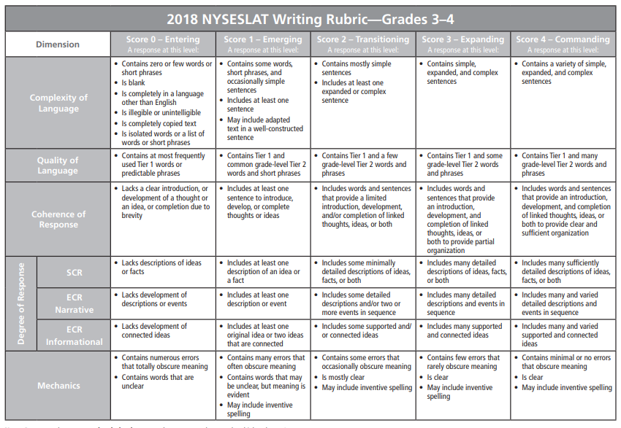

Teacher’ College Reading and Writing Project Opinion Writing Rubric Grade 4
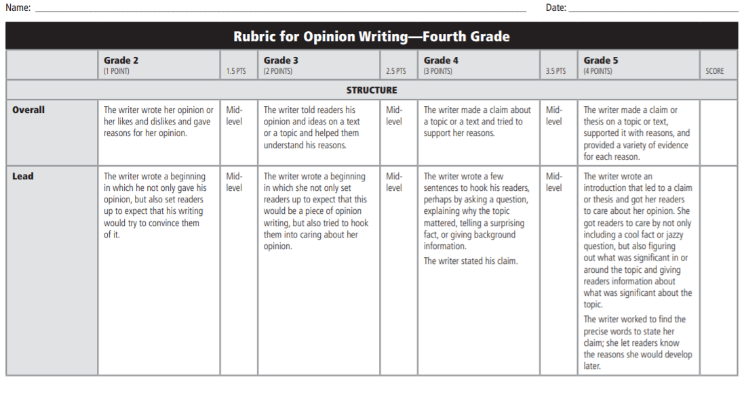 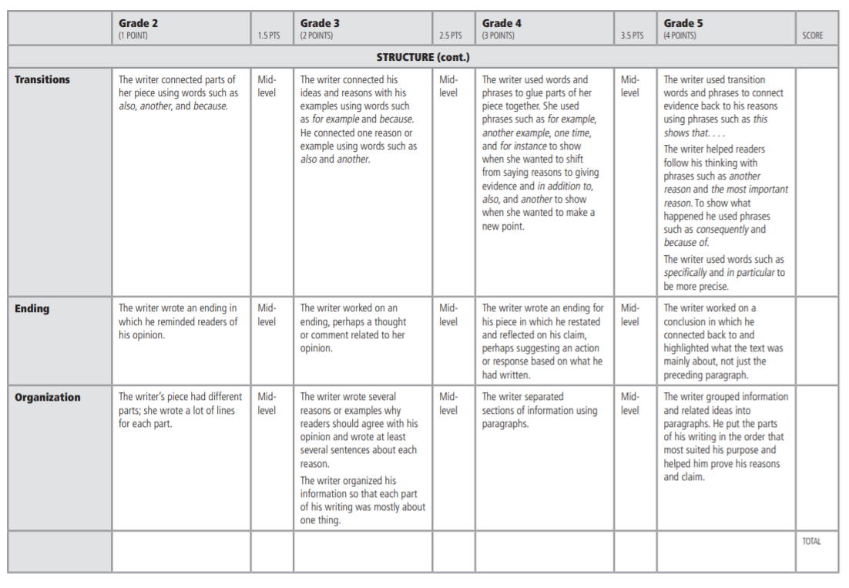 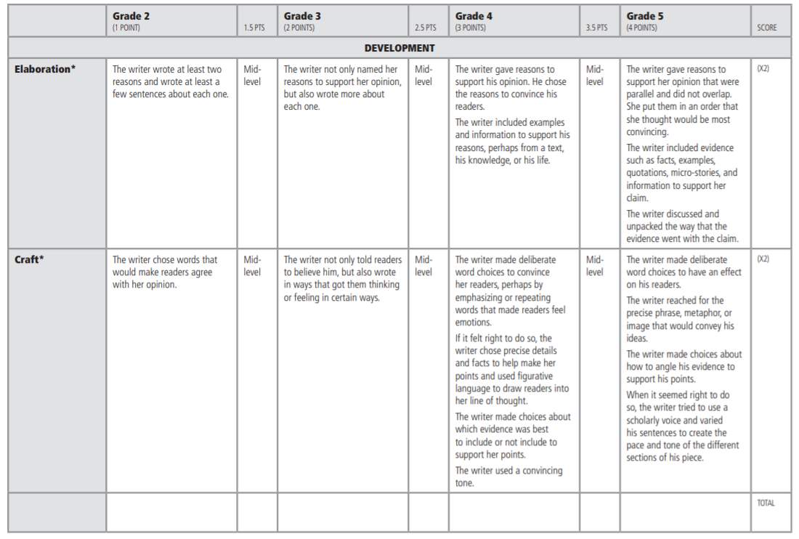 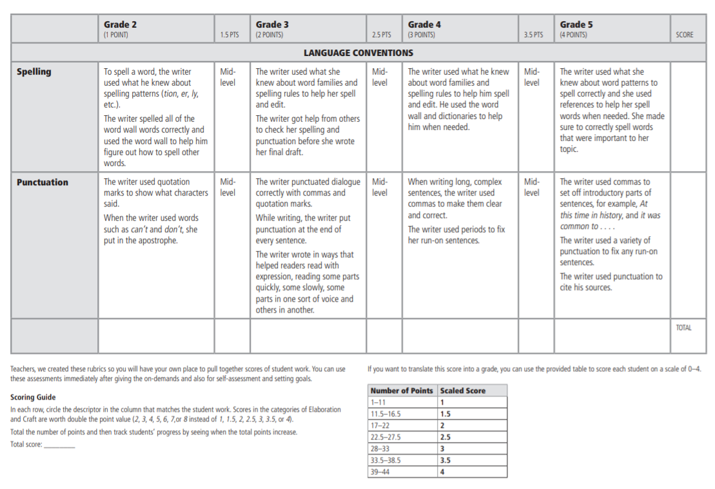References

N.Y.S.E.D. (2015, July 1). English Language Learners (ELLs) Screening, Identification, Placement, Review, and Exit Criteria. NYSED. Retrieved July 1, 2015, from http://www.nysed.gov/common/nysed/files/bilingual/ellidchartguidance7.1.15.pdf

New York State English as a Second Language Achievement Test (NYSESLAT) Resources. (2015, December 17). NYSESLAT Writing Rubric. Retrieved December 17, 2015, from https://www.engageny.org/resource/new-york-state-english-a-second-language-achievement-test-nyseslat-rubrics

